**Department of Science and Humanities**

**Applied Chemistry Laboratory**

**Subject: Engineering Chemistry**

**Name: Pargat Singh**

**Batch: A2**  **Date:** 13/10/21

**Roll No. :** 16010121045

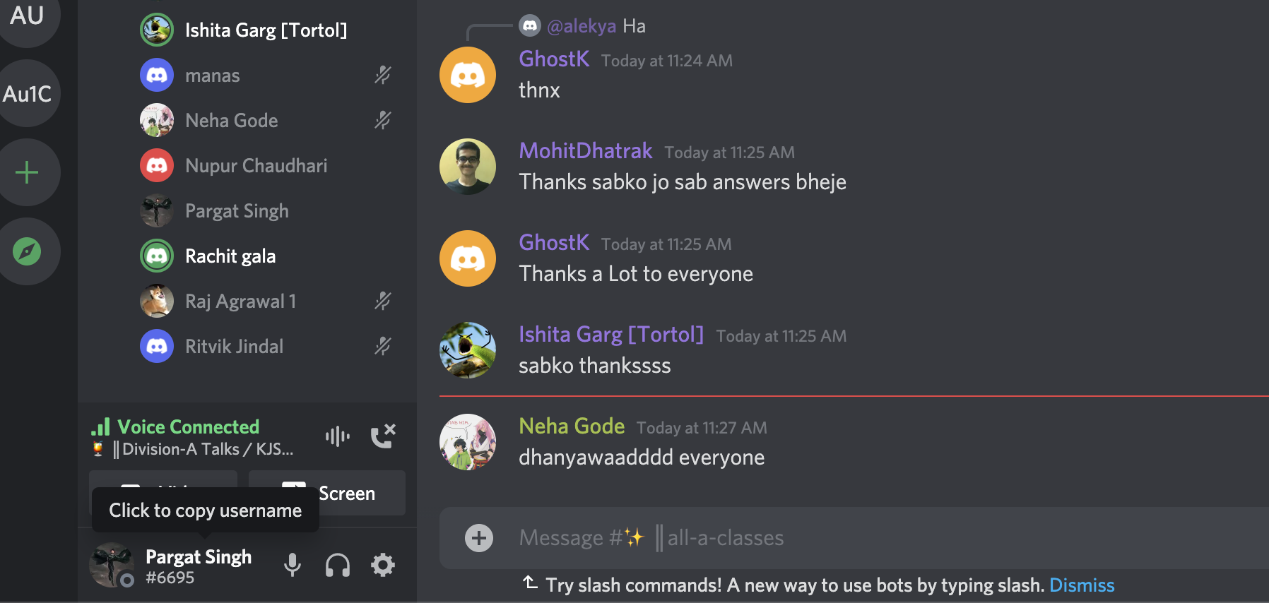

**CO: 1-5 life long learning**

**Experiment No. 1**

**Role of Engineering Chemistry in Day to day Life and familiarization with GLP**

**Aim :** To understand & familiarize with Good Laboratory Practices in Chemistry LaboratorRole of Engineering Chemistry in Day to day Life and familiarization with GLP

**Instructions:**

Following things are required to perform the experiments in the chemistry lab,

**Laboratory Coat:** A laboratory white coat must be worn at all times while in the laboratory when anyone is conducting experiments.

**Closed Shoes:** Wear closed shoes at all times while in the laboratory and confine long hair when in the laboratory

**Scientific Calculator:** This calculator should preferably be equipped with log, ln, exp, and 1/x functions.

**Lab Write-up:** Bring lab write up for all the experiments

**DO’S**

1. Use protective clothing all the time (e.g. lab coat and safety glasses). Wear closed shoes.

2. Be familiar with your lab assignment before you come to lab. Follow all written and verbal instructions carefully. Observe the safety alerts in the laboratory directions. If you do not understand a direction or part of a procedure, ask the teacher before proceeding.

3. Wash acid, base, or any chemical spill off yourself immediately with large amounts of water. Notify your teacher of the spill.

4. Clean up spills immediately. If you spill a very reactive substance such as an acid or base, notify the people in the area and then obtain assistance from your teacher. Acid spills should be neutralized with baking soda, base spills with vinegar before cleaning them up.

**Department of Science and Humanities**

**Applied Chemistry Laboratory**

**Subject: Engineering Chemistry**

5. If chemical substances get in your eye, wash the eye out for 15 minutes. Hold your eye open with your fingers while washing it out.

6. Place the reagents in a systemic manner.

7. If you burn yourself on a hot object, immediately hold the burned area under cold water for 15 minutes. Inform your teacher.

8. Follow above good laboratory practices (GLP). Work areas should be kept clean and tidy at all times. Only lab notebooks or lab handouts should be out on the table while performing an experiment. Books and book bags should not be on the lab table. Passageways need to be clear at all times.

9. Work with dangerous or volatile chemicals in a fume hood as directed by your instructor and/or lab manual.

**DON’T**

1. Do not Work in the laboratory without an instructor present. Do not venture to other lab stations for any reason.

2. Do not wear bulky or dangling clothing.

3. Do not eat or drink in the laboratory.

4. Do not use Mobile Phones.

5. Do not directly touch any chemical with your hands. Never taste materials in the laboratory.

6. Do not enter the lab/ classroom, do not touch any equipment, chemicals, or other materials without being instructed to do so.

7. Never place chemicals directly on the balance pan also not to weigh a hot object.

8. Absolutely no running, practical jokes, or horseplay is allowed in the laboratory.

9. Do not allow the reagent bottles to accumulate on the bench.

10. Do not force glass tubing or thermometers into rubber stoppers. The tubing or thermometer may break and cut you badly. Consult with your laboratory instructor for assistance.

**Department of Science and Humanities**

**Applied Chemistry Laboratory**

**Subject: Engineering Chemistry**

11. Do not perform unauthorized experiments. If you see someone else doing something you think may be dangerous, tell him or her to stop and/or report the incident to your lab instructor. If another student tells you to stop doing something because it is unsafe, stop as directed. Consult your lab instructor if there is a problem or difference of opinion.

**Handling Accidents**

1. **Notify your lab instructor immediately** if you have an accident, spill, or are injured in any way.

2. If chemicals come in contact with your skin or eyes, **wash with water for at least 15 minutes**. It is not recommended to wear contact lenses in the laboratory since chemicals splashed in the eye may get under the lens therefore be difficult to rinse. If a splash occurs while you are wearing contact lenses, they must be safely removed as quickly as possible.

3. Know where to find and how to use the safety shower in the front of the room.

4. Clean up spilled chemicals immediately. Consult your laboratory instructor if you are not sure what to do.

5. Solid sodium bicarbonate (baking soda) is available in the laboratories in containers located by the sinks. Use this to neutralize acid spills before wiping them up. Similarly, solid citric acid solution is available in containers by the sinks and should be used to neutralize base spills before wiping them up. A saturated solution of sodium bicarbonate is also available by the sinks and can be used to wipe dried acid or base residue off of lab benches as needed. However, if acid or base spills on your skin, don't waste time looking for these neutralizing substances. Rinse with water immediately for at least 15 minutes.

**Proper Waste Disposal**

Separate waste as follows:

**Department of Science and Humanities**

**Applied Chemistry Laboratory**

**Subject: Engineering Chemistry**

a. Waste chemicals should be disposed of as directed by your lab instructor. Most chemicals are NOT to be thrown down the sink. Special waste receptacles will be provided for these chemicals. Waste chemicals must be sorted by kind, not just mixed with other, different waste chemicals. Read waste container labels carefully.

Broken glass is to be disposed of in the cardboard boxes labeled "Broken Glass Only" located near the doors to the lab. A dustpan and broom are located in each lab to assist you in cleaning

up broken glass. Do not put broken glass in the regular trash, and do not put anything except broken glass in the broken glass containers.

**Implementation of Control Measures**

**A. When to use fume hoods:**

Hoods should be used WHENEVER POSSIBLE to contain and exhaust toxic, offensive, or flammable materials. Processes that have potential for generating hazardous airborne chemical concentrations must be carried out within a fume hood.

**B. When to use personal protective equipment: Eye Protection** - Safety goggles must be worn by all personnel in the laboratory whenever hazardous chemicals are in use. NO EXCEPTIONS.

**Gloves** - Gloves should be worn to protect the skin from chemical and physical (e.g. heat, cold) exposures. Thermal resistant gloves shall be worn for operations involving the handling of heated materials and exothermic reaction vessels. Thermal resistant gloves shall be non-asbestos and shall be replaced when damaged.

**Department of Science and Humanities**

**Applied Chemistry Laboratory**

**Subject: Engineering Chemistry**

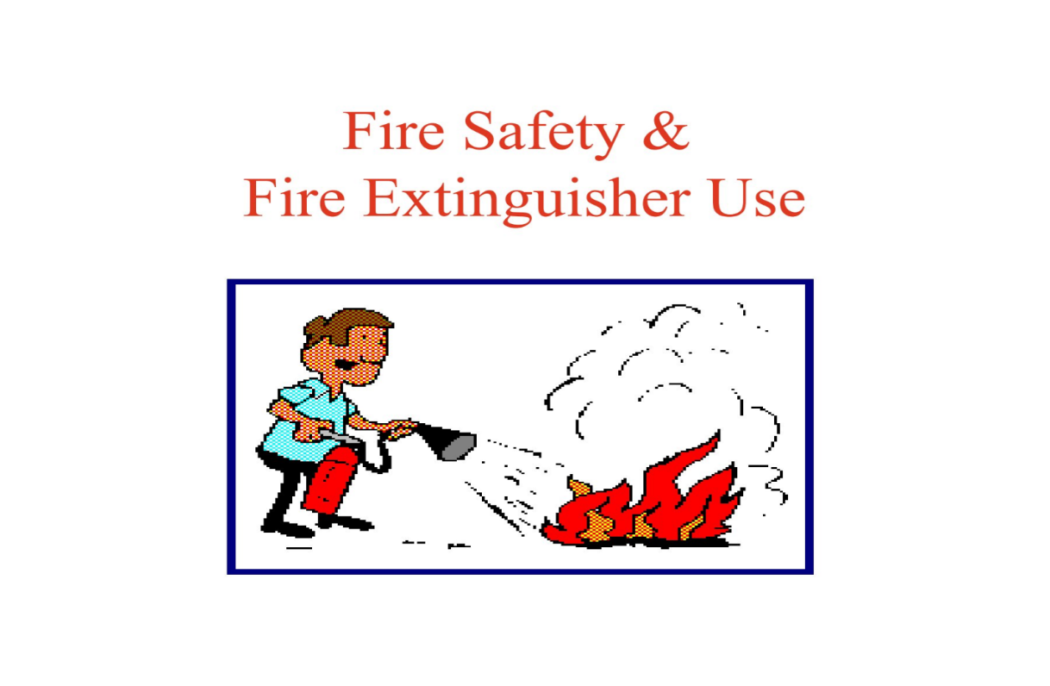

**Department of Science and Humanities**

**Applied Chemistry Laboratory**

**Subject: Engineering Chemistry**

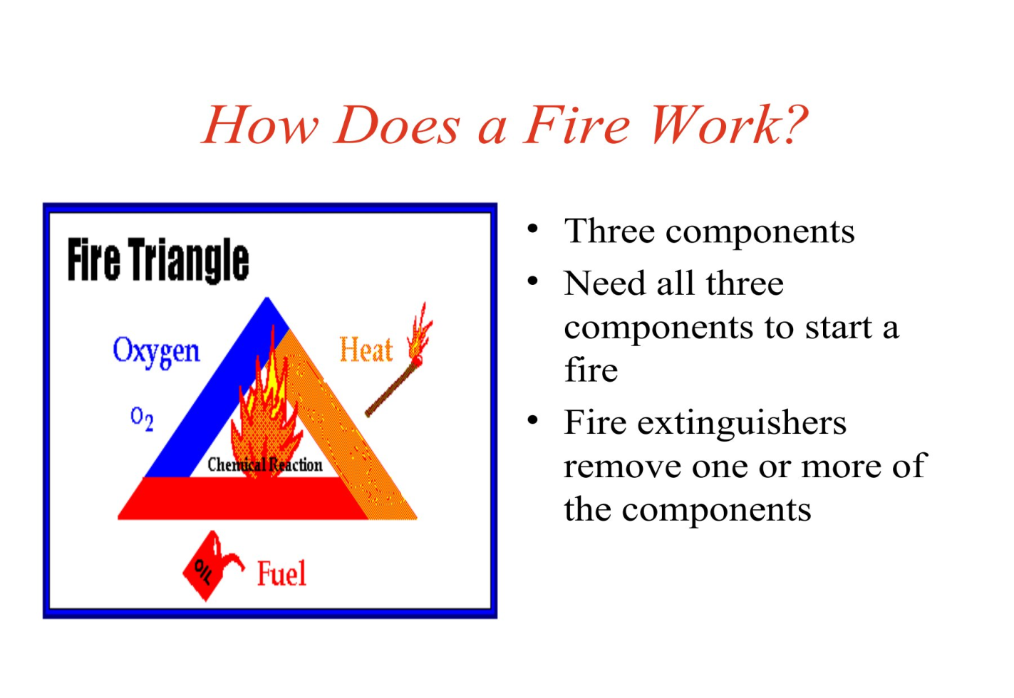

**Department of Science and Humanities**

**Applied Chemistry Laboratory**

**Subject: Engineering Chemistry**

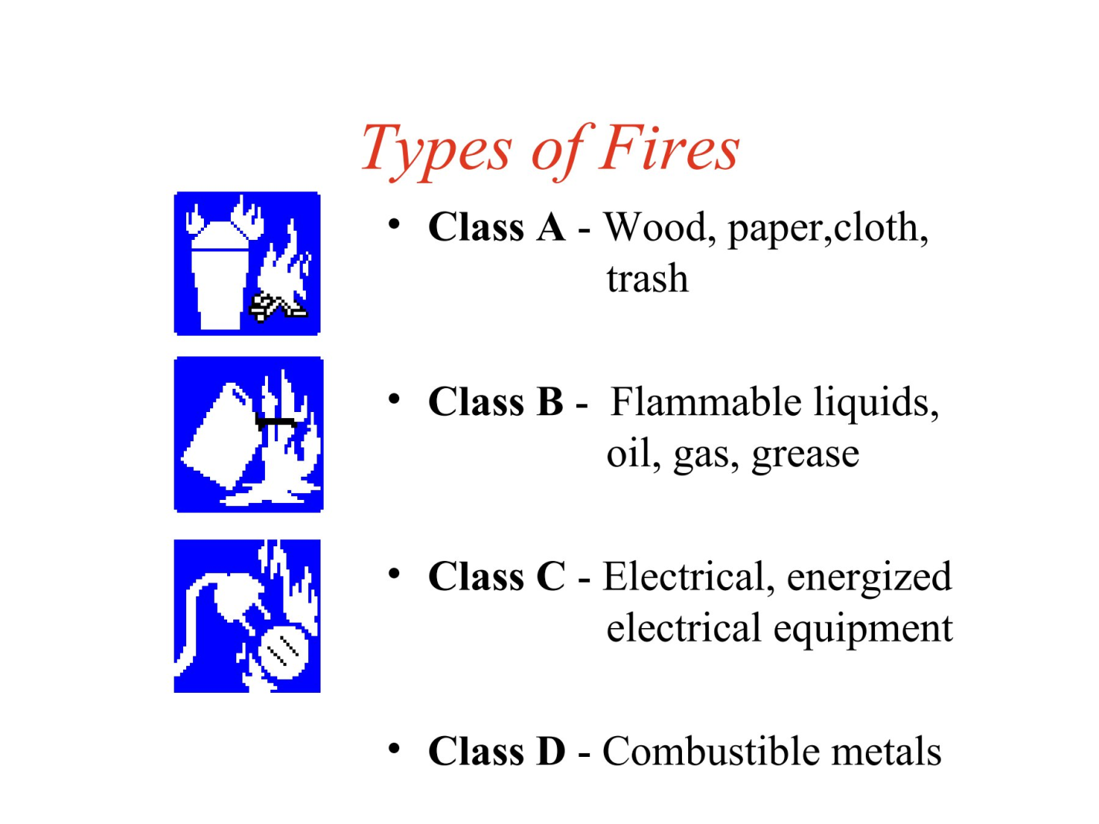

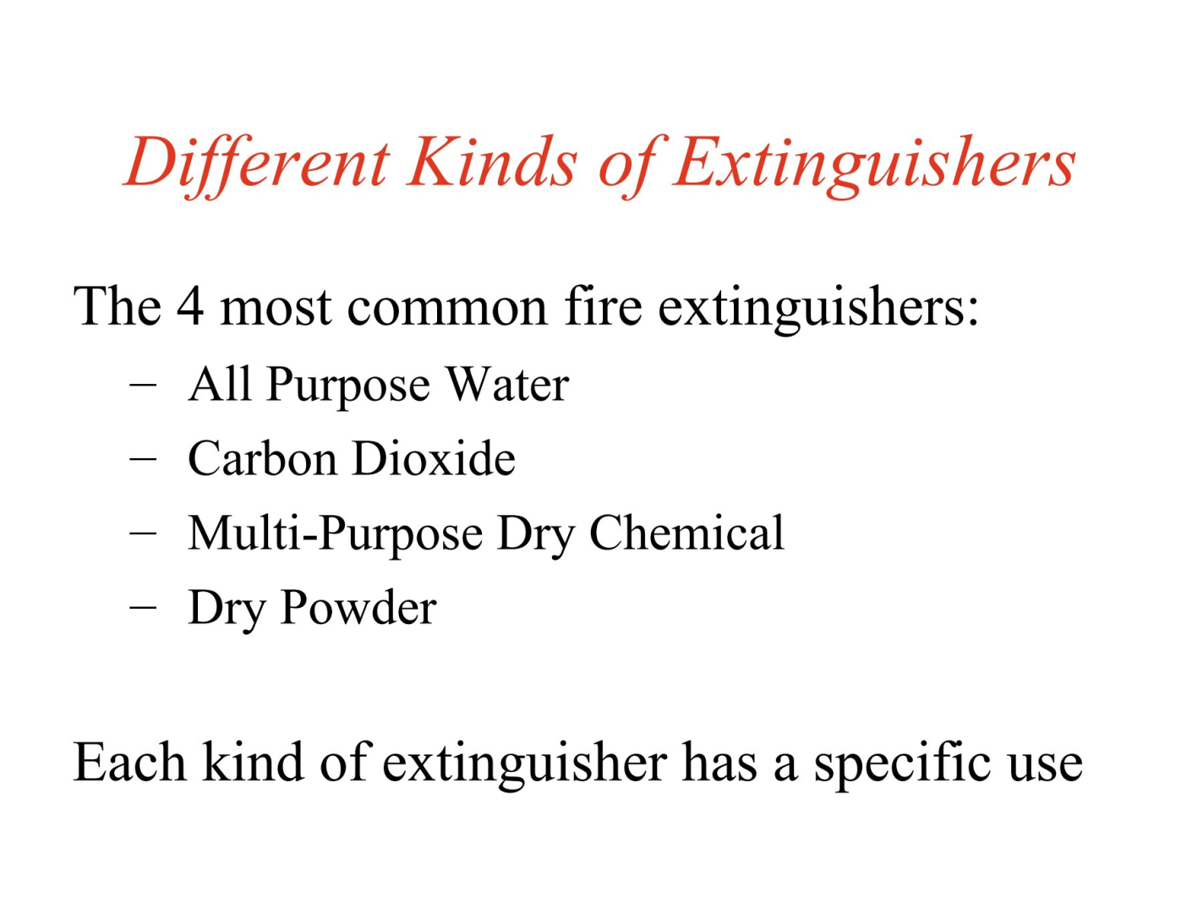

**Department of Science and Humanities**

**Applied Chemistry Laboratory**

**Subject: Engineering Chemistry**

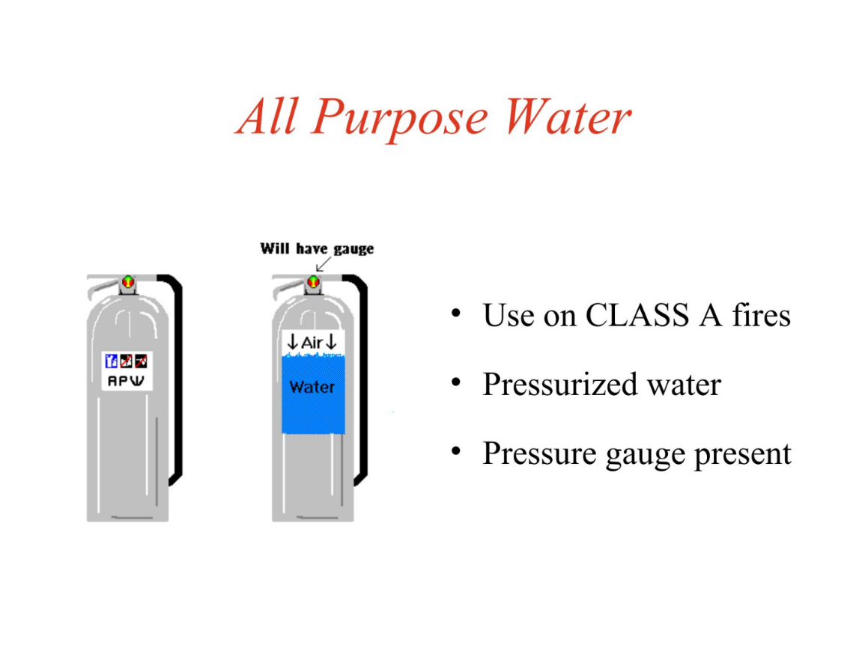

**Department of Science and Humanities**

**Applied Chemistry Laboratory**

**Subject: Engineering Chemistry**

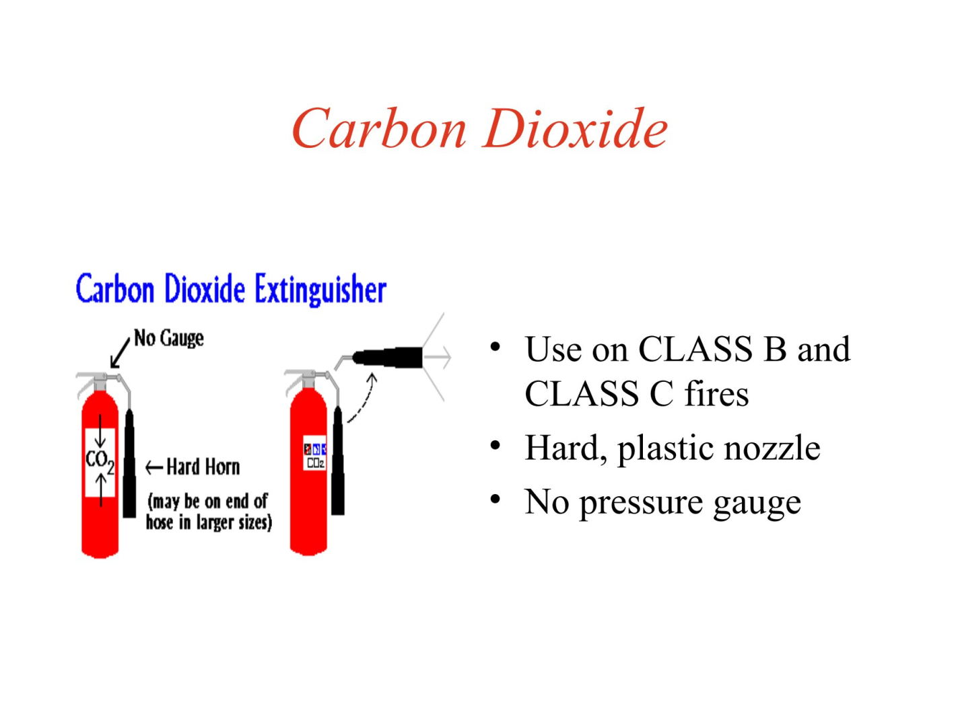

**Department of Science and Humanities**

**Applied Chemistry Laboratory**

**Subject: Engineering Chemistry**

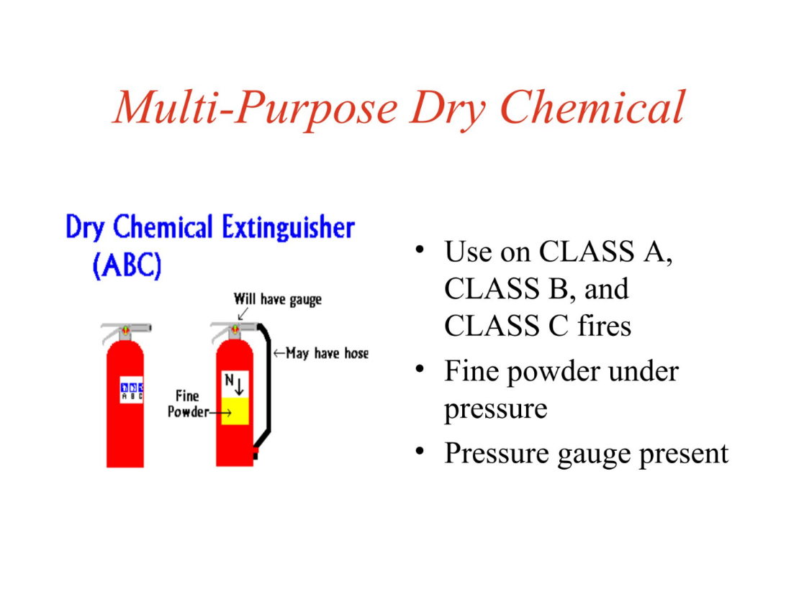

**Department of Science and Humanities**

**Applied Chemistry Laboratory**

**Subject: Engineering Chemistry**

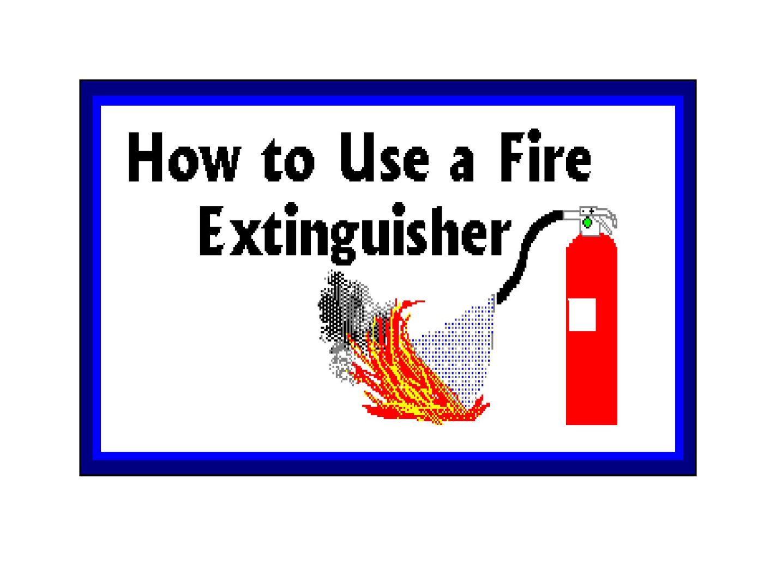

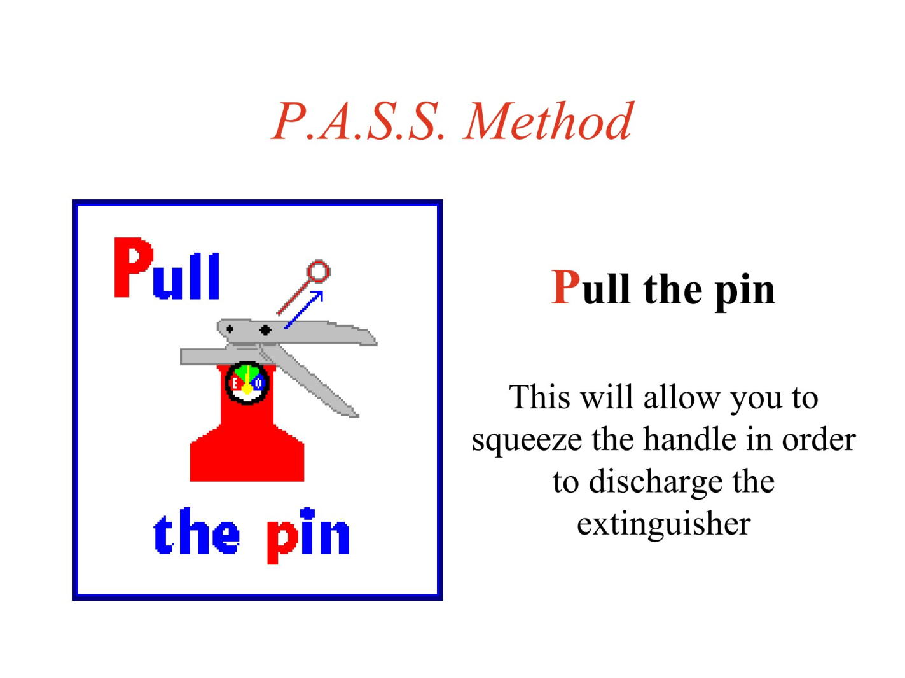

**Department of Science and Humanities**

**Applied Chemistry Laboratory**

**Subject: Engineering Chemistry**

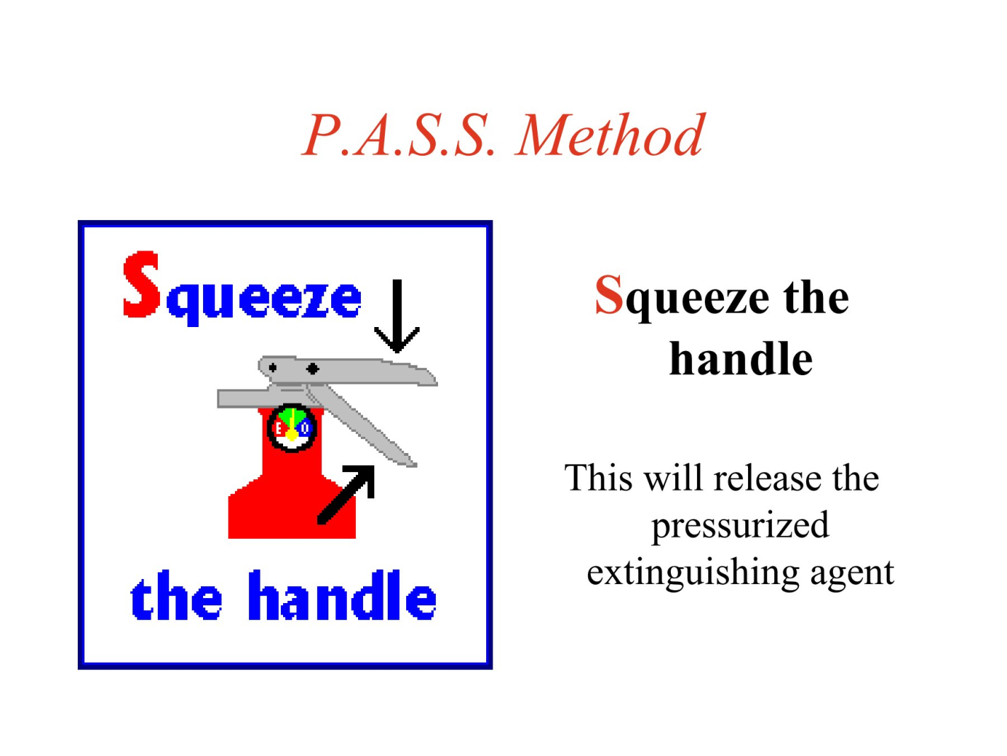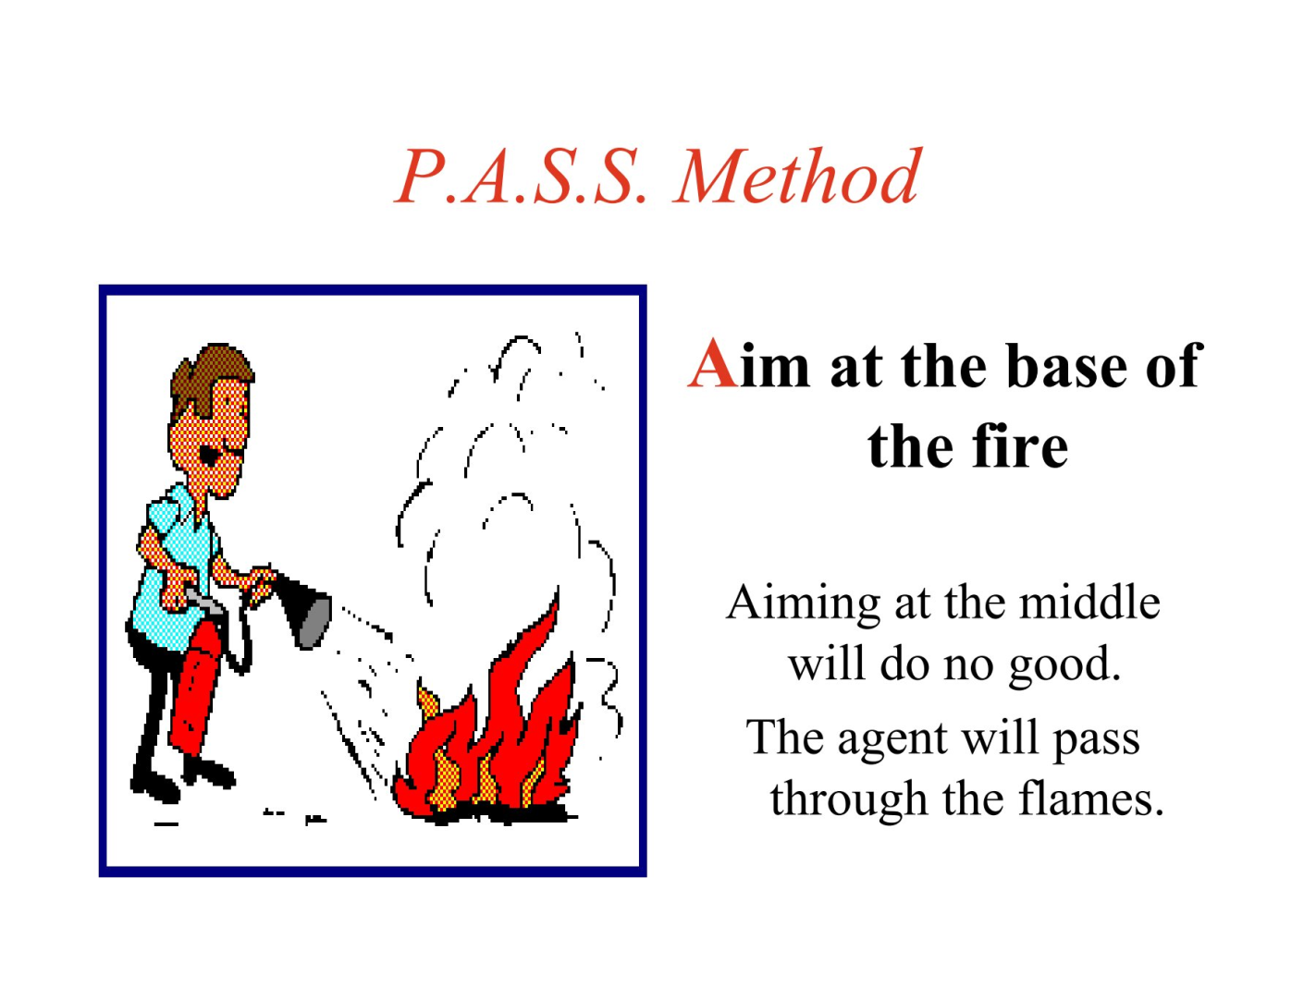

**Department of Science and Humanities**

**Applied Chemistry Laboratory**

**Subject: Engineering Chemistry**

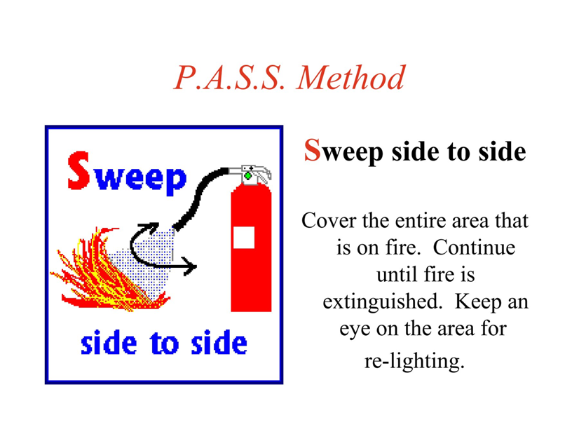

**Department of Science and Humanities**

**Applied Chemistry Laboratory**

**Subject: Engineering Chemistry**

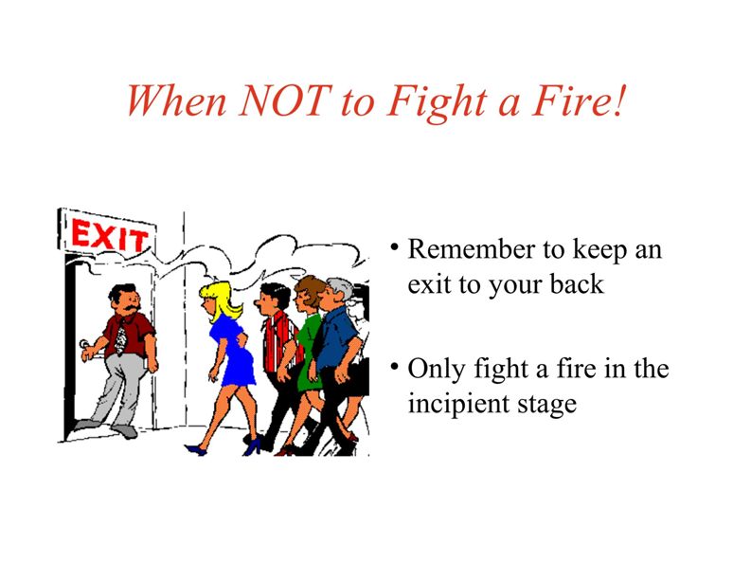

**Department of Science and Humanities**

**Applied Chemistry Laboratory**

**Subject: Engineering Chemistry**

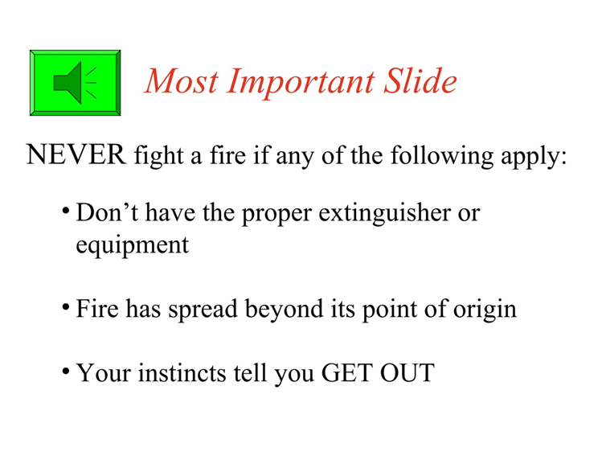

**Department of Science and Humanities**

**Applied Chemistry Laboratory**

**Subject: Engineering Chemistry**

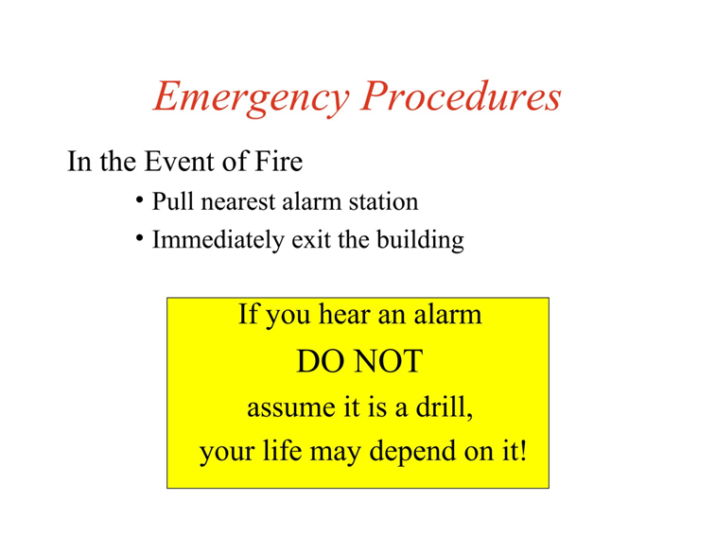

**Department of Science and Humanities**

**Applied Chemistry Laboratory**

**Subject: Engineering Chemistry**

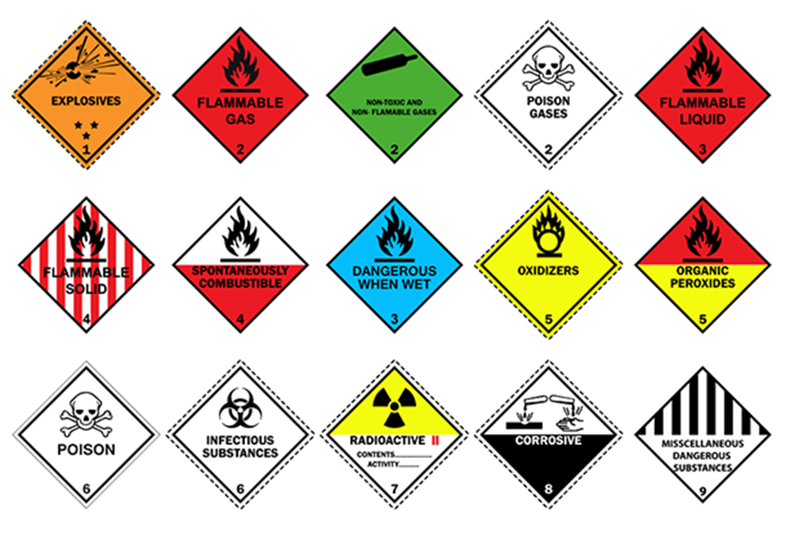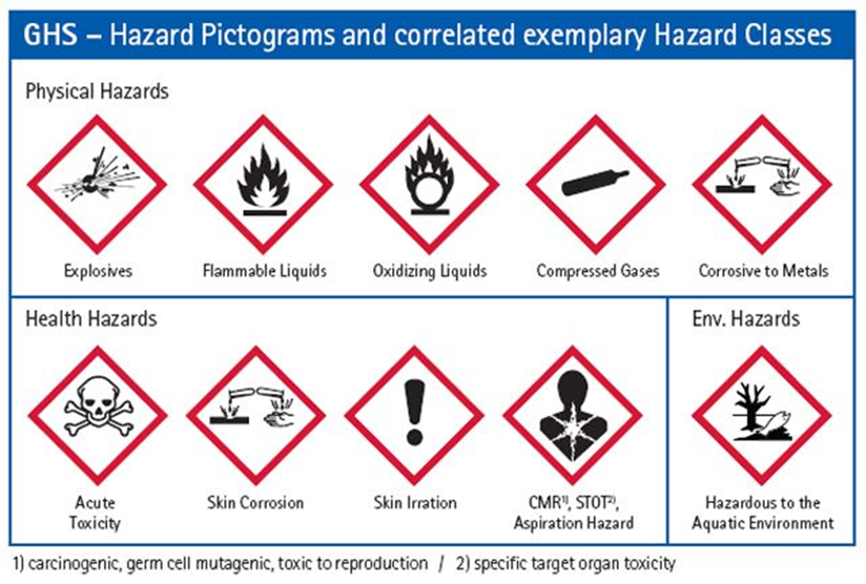

**Department of Science and Humanities**

**Applied Chemistry Laboratory**

**Subject: Engineering Chemistry**

